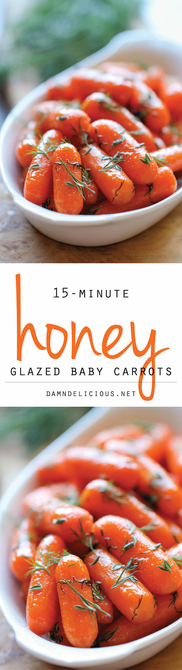
Bob’s Carrots
Ingredients
2 lb small baby carrots
2 cans of beef broth
12 tbsp (1½ sticks) butter
4 heaping tbsp brown sugar
Directions
- Mix together broth, butter and brown sugar in a pan and bring to a boil
- Add carrots and toss to coat.
- Cook til liquid is syrupy, app 40 min -can be covered
- Add salt, pepper and butter to taste

